Documentation Report
Customer Engagement & Service Analytics Platform
Based on uploaded project: CostumerEngagementPlatform-Final-Capstone-Project
Technology Stack: ASP.NET Core MVC, C#, EF Core, SQL Server, Razor Views, Bootstrap, Swagger, JWT
Prepared Date: 06 June 2026

This report documents system architecture, DFD, ER diagram, database design, connectivity, authentication and authorization, JWT implementation, API documentation, business rules, assumptions, future scope, and comparison with live applications.

Table of Contents
1. Project Overview
2. System Architecture Diagram
3. Data Flow Diagrams
4. ER Diagram and Database Design
5. Front End / Back End Connectivity
6. Authentication and Authorization
7. JWT Implementation Steps
8. Report Generation Process
9. API Documentation
10. Business Rules Summary
11. Best Practices Followed
12. Ideal Scenario and Assumptions
13. Future Development Scope
14. Comparison with Live Applications
15. Conclusion

1. Project Overview
The Customer Engagement & Service Analytics Platform is a web application for managing customer records and support tickets. It uses ASP.NET Core MVC for the web interface, Entity Framework Core for database access, SQL Server for persistence, and Swagger for API testing.
Area | Implemented Details
Customer Management | Add, view, edit and delete customers. Fields include name, email, phone and address.
Ticket Management | Create, view, edit and delete support tickets. Fields include subject, description, status, priority and created date.
Security | Cookie-based login for MVC screens, role-based dashboards for Admin and User, access denied page and JWT token generation for API login.
API Layer | AuthApiController, CustomersApiController and TicketsApiController expose REST-style endpoints for login, customer data and ticket data.
Database | ApplicationDbContext defines Customers and Tickets DbSet objects, with EF Core migrations for schema creation and nullable CustomerId in Tickets.

2. System Architecture Diagram
The project follows a layered ASP.NET Core MVC architecture. Users interact with Razor views, controllers process requests and business workflows, EF Core handles data access, and SQL Server stores application records.
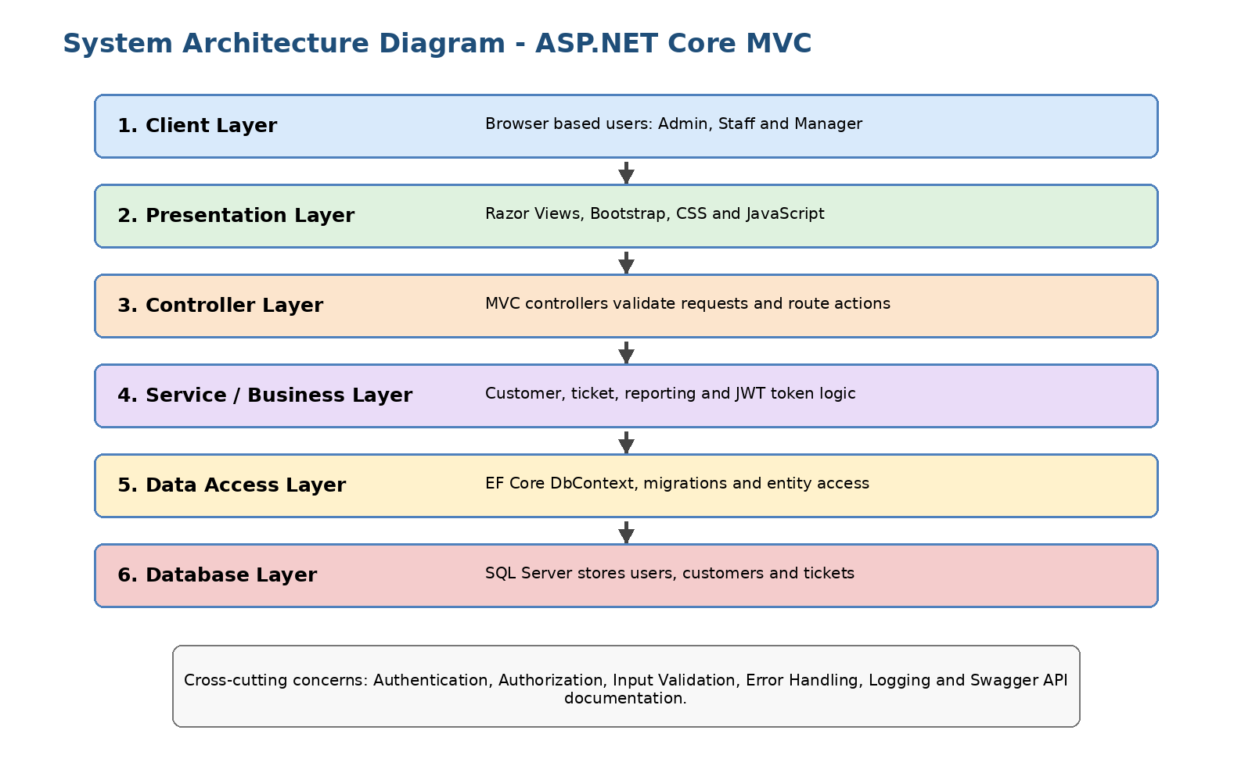
Figure 1: System Architecture Diagram with clearly labelled ASP.NET Core MVC layers.
Layer | Project Folder / Component | Responsibility
Presentation Layer | Views, wwwroot, Bootstrap, Tag Helpers | Display pages, collect input and present validation messages.
Business Logic Layer | Controllers folder | Handle MVC actions, API methods, authentication workflow and CRUD operations.
Data Access Layer | Models, Data, Migrations | Map entities, execute EF Core queries and manage migrations.
Database Layer | SQL Server | Persist Customers and Tickets tables.
Security Layer | AccountController, AuthApiController, Program.cs | Authenticate users, assign roles, protect dashboards and issue JWT tokens.

3. Data Flow Diagrams
The DFD shows how Admin/User requests move through the platform and how the application reads and writes customer and ticket records.
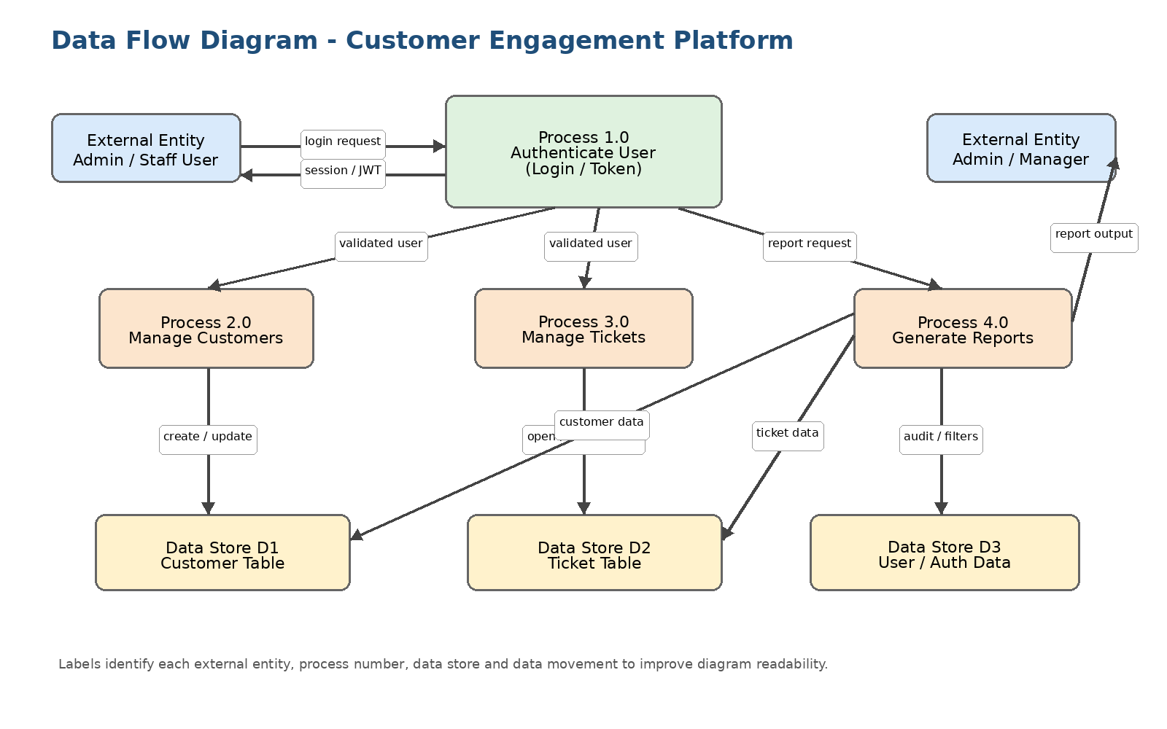
Figure 2: Data Flow Diagram with labelled external entities, processes, data stores and data movement.
Process | Input | Output
Authenticate User | Username and password | Signed-in cookie session for MVC or JWT token for API login.
Manage Customers | Customer form fields | Customer record created, listed, edited or deleted.
Manage Tickets | Ticket form fields | Ticket record created, listed, edited or deleted.
API Access | HTTP request through Swagger/Postman | JSON response with customer, ticket or token data.

4. ER Diagram and Database Design
The database contains two main entities: Customer and Ticket. The current model allows Ticket.CustomerId to be nullable, so a ticket can be created without an assigned customer. The initial migration created a required relationship; a later migration changed CustomerId to optional.
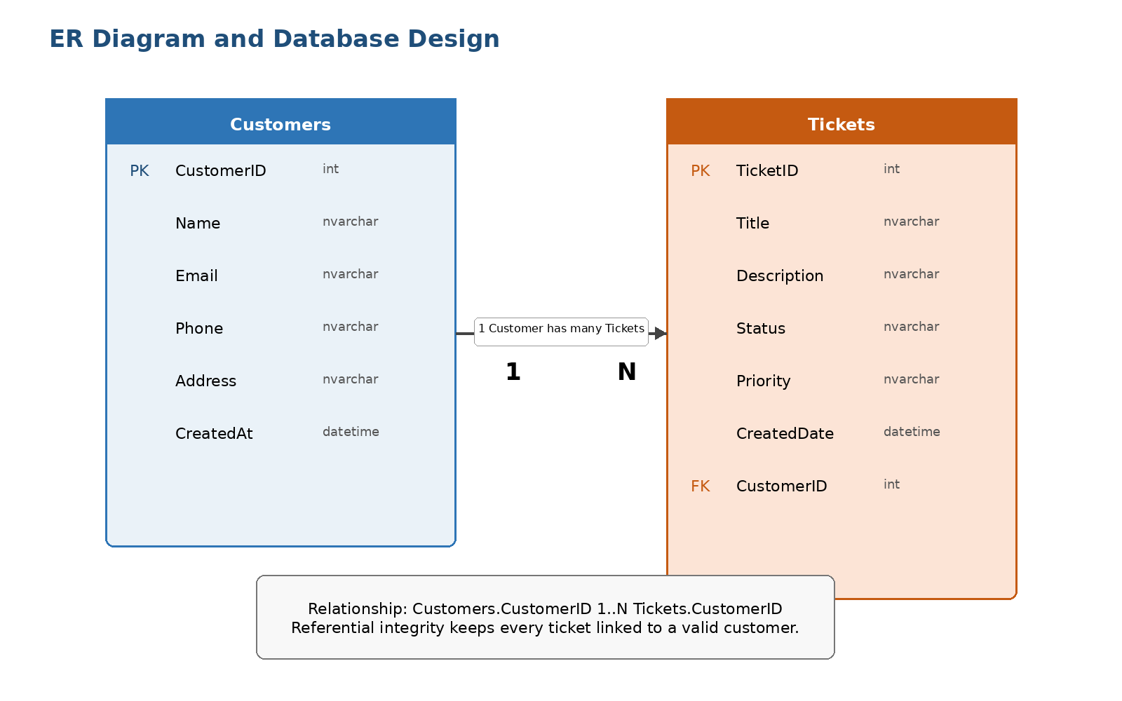
Figure 3: ER Diagram showing Customers, Tickets, primary keys, foreign key and 1:N relationship.
Table | Column | Type / Rule | Description
Customers | CustomerId | int, identity, primary key | Unique customer identifier.
Customers | Name | nvarchar(100), required | Customer full name.
Customers | Email | nvarchar(max), required, EmailAddress validation | Customer email address.
Customers | Phone | nvarchar(max), required | Customer contact number.
Customers | Address | nvarchar(max), nullable | Optional address.
Tickets | TicketId | int, identity, primary key | Unique support ticket identifier.
Tickets | Subject | nvarchar(max), required | Short title of issue.
Tickets | Description | nvarchar(max), required | Detailed issue description.
Tickets | Status | nvarchar(max), default Open | Current ticket status.
Tickets | Priority | nvarchar(max), default Medium | Ticket priority level.
Tickets | CreatedDate | datetime2, default DateTime.Now | Ticket creation date.
Tickets | CustomerId | int, nullable, foreign key | Optional link to Customers.CustomerId.

Database Design Notes
- ApplicationDbContext exposes DbSet<Customer> Customers and DbSet<Ticket> Tickets.
- Entity Framework Core migrations are present for initial schema creation and for making Ticket.CustomerId optional.
- The Customer entity has a collection navigation property for Tickets, supporting one-to-many navigation.
- The Ticket entity has a nullable Customer navigation property and nullable CustomerId foreign key.

5. Important Steps for Front End / Back End Connectivity
The MVC flow connects Razor views to controllers and then to the database through dependency-injected EF Core services.
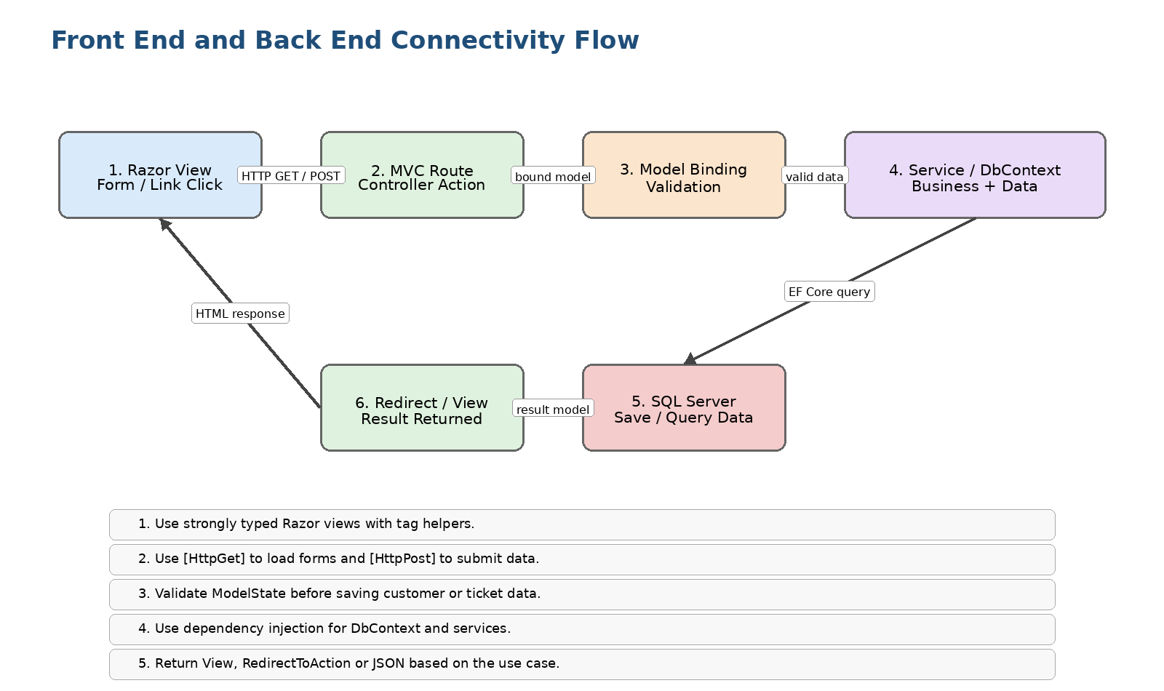
Figure 4: Front End and Back End Connectivity Flow showing request, validation, service and database layers.
- Create model classes with validation attributes such as [Required], [EmailAddress] and [StringLength].
- Register MVC services using AddControllersWithViews in Program.cs.
- Register ApplicationDbContext with SQL Server connection string using AddDbContext.
- Inject ApplicationDbContext into CustomersController and TicketsController using constructor injection.
- Create Razor forms with asp-for fields and submit them to controller actions.
- Use ModelState.IsValid to validate input before saving.
- Use async EF Core methods such as ToListAsync, FindAsync and SaveChangesAsync.
- Return views for validation errors and redirect to Index after successful operations.
builder.Services.AddDbContext<ApplicationDbContext>(options =>
options.UseSqlServer(builder.Configuration.GetConnectionString("DefaultConnection")));

6. User Validation via Authentication and Authorization
The MVC application uses cookie-based authentication. AccountController checks demo credentials, creates claims for username and role, signs in the user, and redirects to a role-specific dashboard.
User Type | Credentials in Project | Authorized Pages / Actions
Admin | admin / admin123 | Admin Dashboard, customer management, ticket management and administrative workflow.
User | user / user123 | User Dashboard and limited ticket viewing workflow.
Authorization is implemented with role attributes on dashboard actions:
[Authorize(Roles = "Admin")]
public IActionResult AdminDashboard() { ... }
[Authorize(Roles = "User")]
public IActionResult UserDashboard() { ... }
Program.cs configures the login page and access denied route for the cookie authentication middleware:
builder.Services.AddAuthentication(CookieAuthenticationDefaults.AuthenticationScheme)
.AddCookie(options =>
{
options.LoginPath = "/Account/Login";
options.AccessDeniedPath = "/Account/AccessDenied";
});

7. Steps for JWT Implementation
The uploaded project contains AuthApiController for API login and JWT token generation. The token includes username and role claims, uses HmacSha256 signing, and expires after one hour.
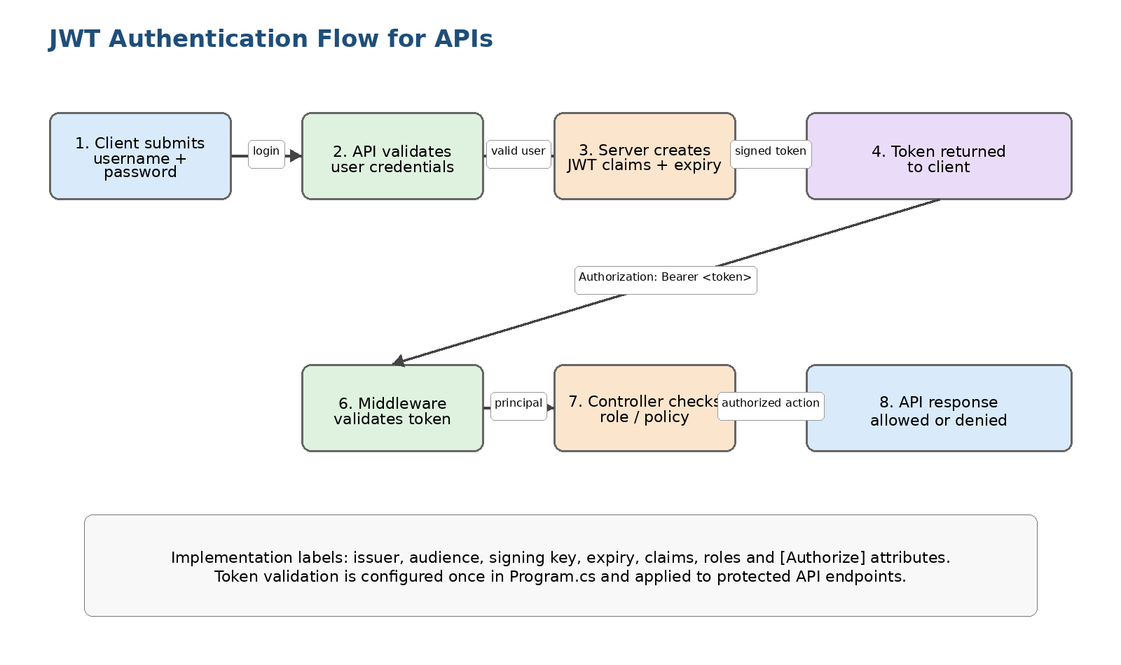
Figure 5: JWT Authentication Flow with labelled login, token creation, middleware validation and authorization steps.
- Install JWT bearer package: Microsoft.AspNetCore.Authentication.JwtBearer is referenced in the project file.
- Create an API login endpoint: POST /api/AuthApi/login.
- Validate username and password against the configured users or a future Users table.
- Create claims, including ClaimTypes.Name and ClaimTypes.Role.
- Create SymmetricSecurityKey from the secret key and signing credentials using SecurityAlgorithms.HmacSha256.
- Generate JwtSecurityToken with issuer, audience, claims, expiry and signing credentials.
- Return the token to the client as JSON.
- Client calls APIs by sending Authorization: Bearer <token> header.
- Recommended next step: configure AddJwtBearer in Program.cs and add [Authorize] attributes on API controllers to validate tokens on incoming API calls.
var token = new JwtSecurityToken(
issuer: "CustomerEngagementPlatform",
audience: "CustomerEngagementUsers",
claims: claims,
expires: DateTime.Now.AddHours(1),
signingCredentials: credentials);

8. Report Generation Process
The README lists Reporting Module as a future enhancement. The following process can be used to implement reporting based on the current Customers and Tickets data model.
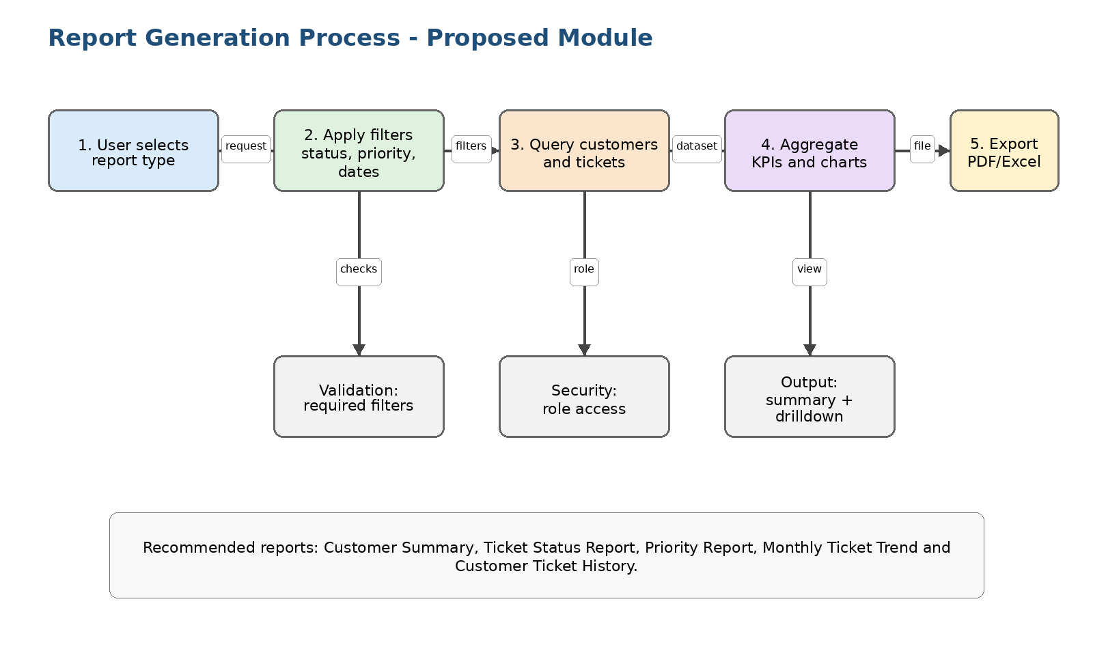
Figure 6: Proposed Report Generation Process with labelled filters, data query, aggregation and export steps.
Report | Source Data | Business Value
Customer Summary | Customers table | Total customers and customer list export.
Ticket Status Report | Tickets.Status | Count of Open, In Progress and Closed tickets.
Priority Report | Tickets.Priority | Understand workload severity by Low, Medium and High priority.
Monthly Ticket Trend | Tickets.CreatedDate | Track service demand over time.
Customer Ticket History | Customers joined with Tickets | View service interactions for a customer.

9. API Documentation: Swagger / Postman Style Summary
Swagger is enabled in Program.cs using AddSwaggerGen, UseSwagger and UseSwaggerUI. The application exposes API controllers that can be tested from /swagger or exported to Postman after generating an OpenAPI document.
Method | Endpoint | Controller Action | Request Body / Parameters | Response
POST | /api/AuthApi/login | AuthApiController.Login | username, password | 200 OK with { Token }, or 401 Unauthorized.
GET | /api/CustomersApi | CustomersApiController.GetCustomers | None | 200 OK with customer list.
GET | /api/CustomersApi/{id} | CustomersApiController.GetCustomer | id route parameter | 200 OK with customer, or 404 NotFound.
POST | /api/CustomersApi | CustomersApiController.CreateCustomer | Customer JSON | 200 OK with created customer.
GET | /api/TicketsApi | TicketsApiController.GetTickets | None | 200 OK with ticket list.
GET | /api/TicketsApi/{id} | TicketsApiController.GetTicket | id route parameter | 200 OK with ticket, or 404 NotFound.
POST | /api/TicketsApi | TicketsApiController.CreateTicket | Ticket JSON | 200 OK with created ticket.

Sample API Payloads
POST /api/AuthApi/login?username=admin&password=admin123
Response: { "token": "<jwt-token>" }
POST /api/CustomersApi
{
"name": "Rahul Sharma",
"email": "rahul@example.com",
"phone": "9876543210",
"address": "Mumbai"
}
POST /api/TicketsApi
{
"subject": "Login issue",
"description": "Customer cannot login",
"status": "Open",
"priority": "High",
"customerId": 1
}

10. Business Rules Summary
Rule Area | Business Rule Implemented / Implied
Customer Validation | Customer name, email and phone are required. Name is limited to 100 characters. Email must follow email format validation.
Ticket Validation | Ticket subject and description are required. Status defaults to Open and priority defaults to Medium.
Ticket Ownership | Ticket can optionally be linked to a customer through CustomerId. This supports unassigned/general tickets.
Authentication | Only matching demo credentials are accepted for MVC login and API token generation.
Authorization | Admin and User dashboards are separated using role-based authorization attributes.
CRUD Workflow | Create and edit operations save only when ModelState is valid. Delete removes the selected entity when it exists.
API Result Handling | Get by id returns NotFound when the requested customer or ticket does not exist.

11. Best Practices Followed in the Project
Best Practice | Evidence in Project | Benefit
Layered MVC architecture | Views, Controllers, Models, Data and Migrations are separated. | Improves maintainability and separation of concerns.
Dependency Injection | ApplicationDbContext is injected into controllers. | Reduces tight coupling and improves testability.
Async database access | Controllers use ToListAsync, FindAsync and SaveChangesAsync. | Improves scalability for I/O-bound operations.
Model validation | Data annotations are used in Customer, Ticket and LoginViewModel. | Prevents incomplete or invalid form submissions.
Anti-forgery protection | MVC POST actions include ValidateAntiForgeryToken. | Reduces CSRF risk in form-based requests.
Role-based authorization | Authorize attributes protect AdminDashboard and UserDashboard. | Controls access based on role.
Swagger integration | Swagger services and middleware are configured. | Supports API testing and documentation.
EF Core migrations | Migration files are included. | Provides versioned database schema management.
Centralized routing/middleware | Program.cs configures HTTPS redirection, static files, routing, authentication and authorization. | Creates a clear application startup pipeline.

Recommended Industry Improvements
- Move hardcoded credentials and JWT secret key to secure configuration or a secret manager.
- Configure AddJwtBearer middleware and protect API endpoints with [Authorize].
- Replace demo login with an Identity Users table and password hashing.
- Add pagination, filtering and sorting for list pages and APIs.
- Use DTOs for API input/output to avoid over-posting and exposing entity details.
- Add structured logging and exception handling for API failures.
- Add unit tests and integration tests for controllers, validation and business rules.

12. Ideal Scenario and Assumptions
An ideal usage scenario demonstrates how the platform should behave in a real business setting.
- An admin logs in using valid credentials and opens the Admin Dashboard.
- The admin creates customer records with valid contact details.
- A user or admin creates a support ticket with subject, description, priority and optional customer mapping.
- The service team updates ticket status from Open to In Progress and then Closed.
- Managers review ticket status reports to identify pending work and high-priority issues.
- External tools use Swagger/Postman to test APIs and receive JSON responses.
Assumptions used for this documentation:
- The project is intended as a capstone/demo application rather than a production deployment.
- Admin and User credentials are sample credentials and should be replaced in production.
- JWT generation exists for API login; complete API token validation is recommended as a next enhancement.
- Report generation is treated as a proposed module because the README lists it under future enhancements.

13. Scope of Future Development
Module | Future Work | Why It Matters
Advanced Analytics Dashboard | Charts for tickets by status, priority and month. | Gives managers operational visibility.
Reporting Module | PDF and Excel exports with date filters. | Supports audits, submissions and business reviews.
Email Notifications | Send email when tickets are created, assigned or closed. | Improves customer communication.
Complete JWT Security | Add JWT bearer validation and [Authorize] on API controllers. | Makes API access secure.
User Management | Use ASP.NET Core Identity, hashed passwords and database-backed roles. | Production-grade authentication.
Ticket Assignment | Assign tickets to agents, add comments and SLA due dates. | Supports real service desk workflows.
Search and Filters | Filter by customer, status, priority and date range. | Improves usability with large data.
Cloud Deployment | Deploy to Azure App Service or containers with SQL database. | Makes application accessible for real users.
Audit Trail | Track create/update/delete actions and user identity. | Supports accountability and compliance.

14. Comparison with Live Applications
The project can be compared with live customer support platforms such as Zendesk, Freshdesk, Zoho Desk or ServiceNow. Those platforms are larger, but the capstone project implements the foundational modules needed for a service-ticket system.
Feature | This Project | Typical Live Application
Customer Records | Basic customer CRUD. | Customer profiles with history, segmentation and omnichannel context.
Ticket Management | Basic CRUD with status and priority. | Assignment, SLA, comments, attachments, escalation and automation.
Authentication | Demo cookie login and role dashboards. | SSO, MFA, password policies, audit logs and enterprise roles.
APIs | Basic customer/ticket APIs and token generation. | Versioned APIs, OAuth/JWT validation, rate limits and API keys.
Reporting | Proposed future module. | Real-time dashboards, exports, custom analytics and scheduled reports.
Deployment | Local ASP.NET Core application with Dockerfile. | Cloud-hosted, scalable, monitored and highly available.
Best Fit | Academic/capstone prototype and learning project. | Production customer support operations.

15. Conclusion
The Customer Engagement & Service Analytics Platform demonstrates a practical ASP.NET Core MVC implementation with customer management, ticket management, role-based login, EF Core database integration, Swagger APIs and JWT token generation. The architecture is suitable for a capstone project and can be extended into a more production-ready service management system by adding database-backed users, complete JWT validation, reporting, analytics, notifications, deployment automation and improved security controls.

